Creating the Team Entity Relationship Diagram
Getting Started With Enterprise Architect

Creating the Team Entity Relationship Diagram 1
None of this has to be perfect! 1
Documentation Standards 1
The Chen Notation 1
The Crows Foot Notation 2
UML Notation 3
Which is best? 3
Things to Consider when Designing your Tables 4
Always Decompose Many to Many Relationships 5
One to One Relationships 6
Creating Entity Relationship Diagrams in Enterprise Architect 6
Starting Enterprise Architect 6
Create a new Project 7
Creating System Views 10
Creating the ERD 15
Creating Entities 17
Creating Relationships 21
Specifying Multiplicity 23
Creating the Data Dictionary 24

Creating the Team Entity Relationship Diagram
Once the system specification is mostly OK and you have an idea of what you are doing as a team and as individuals a good place to start is looking at the data requirements for the system you propose to build.
I am assuming that you will have had some experience with database design and creating appropriate documentation so some of this will be revision.

None of this has to be perfect!
You have a very tight time scale for the first deliverables of this module and that is likely to result in creating a sense of panic.
DON’T PANIC!
You are creating early drafts of these documents and your first sprint meeting will be an opportunity to gain feedback on your early designs.
It doesn’t matter if the designs are not quite right at this stage.
Do what you can with the time you have to create an initial set of documents.
We are creating an ERD early on as it feeds into the System Specification documents.
Remember I said that if you each take a table for development you will have similar amounts of work to complete?
It is harder to imagine the design of the tables if we haven’t done a little database design early on.

Documentation Standards
There are three documentation standards currently to be aware of.

The Chen Notation
An example of the Chen notation is as follows.

House

Site
1
M
On
In this example we are stating that a house is on one site.
A house must be on a site.
A site may or may not have many houses.
This form of notation is a powerful tool in describing the relationship of one entity to another. The main difficulty people new to the notation find is how to read and write in this way.
The dots indicate the membership class of related entities.
They are read like so…
1

House

Site
On
A house must be on one site.

And the return journey…

Houses
1

Site
Has
A site
may or may not have
many
houses

M

The Crows Foot Notation
The Crows Foot Notation is not dissimilar to the Chen Notation
Here our house - site relationship would be represented as follows.

House

Site

The degrees of association are represented like so.
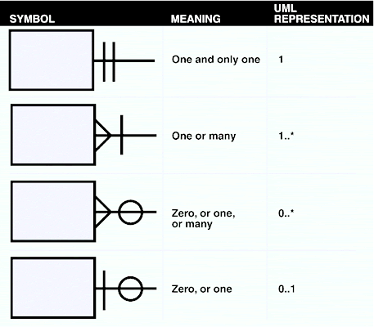

UML Notation
The last notation style you might come across is the UML notation.
This is pretty much the same as the notation we use for describing classes.
Here our house - site relationship would be represented as follows.

House

Site
0..*
1

Which is best?
To some degree it comes down to familiarity and personal preference.
It also comes down to what standard you are told to use and in our case which standard the software we are using i.e. Enterprise Architect “encourages” us to use.
For this module we will be using Chen notation.
Whatever notation standard you use...
- Use it correctly
- Use it consistently throughout the project
- All members need to use the same standard for your team
Which brings is nicely onto the next topic.

Things to Consider when Designing your Tables
There must be no row order significance:
shelf | product | price
A | butter | 89
 | lard | 37
B | bread | 62
 | milk | 32

In this example we are insisting that the rows must be sorted as above otherwise we won’t know what shelf a product is on.
No column order significance:
student# | name
0427h | smith | david | ivan

As above we are assuming that the columns must always be in this order otherwise we won’t know the person’s name.
Each attribute value must have only a single value:
car | make | engine-size
astra | vauxhall | 1100,1300
No duplication:
box# | contents | colour
31 | sugar | brown
47 | flour | white
9 | rice | white
47 | flour | white
103 | sugar | white

As few null values as possible: (!)
vehicle | wheels
car | 4
hovercraft

Null values may arise because they are not known or not applicable. (Or is our design incorrect?)

Always Decompose Many to Many Relationships

Order

Product

Many to many relationships are normally a sign that you have missed an important entity.
You may not know what the missing entity is but they decompose along the following lines…

Order

Product

Order Line

One to One Relationships
Do not exist (probably).
As rule if you end up with the following in your ERD…

A

B
You can be reasonably sure that you have misunderstood something.
(They do exist but they are very rare!)

Creating Entity Relationship Diagrams in Enterprise Architect

Starting Enterprise Architect
Enterprise Architect (EA) is a powerful tool allowing us to draw the diagrams we need to describe our system. In this module we will only be scratching the surface of EA to generate key documents we are interested in.
It is a good idea also to think about how many Enterprise Architect files you are going to need.
Given the members of the team...
- Rod Staff management system
Allowing adding, editing, deleting, listing and filtering of staff records
- Jane Customer management system
Allowing adding, editing, deleting, listing and filtering of customer data
- Freddie Stock management system
Allowing for maintenance of stock data, add, edit etc...
- Bungle Order processing
Allowing for customers to input an order and for staff to process that order to dispatch
Each team member could create their own individual file each and create a single master file for the documents you will create as a team, namely the ERD and the Class Diagram.
Also give a little thought of what and how you plan to share with each other.
You should find EA somewhere off the start menu.
When the program has started you should be presented with a screen similar to the following…
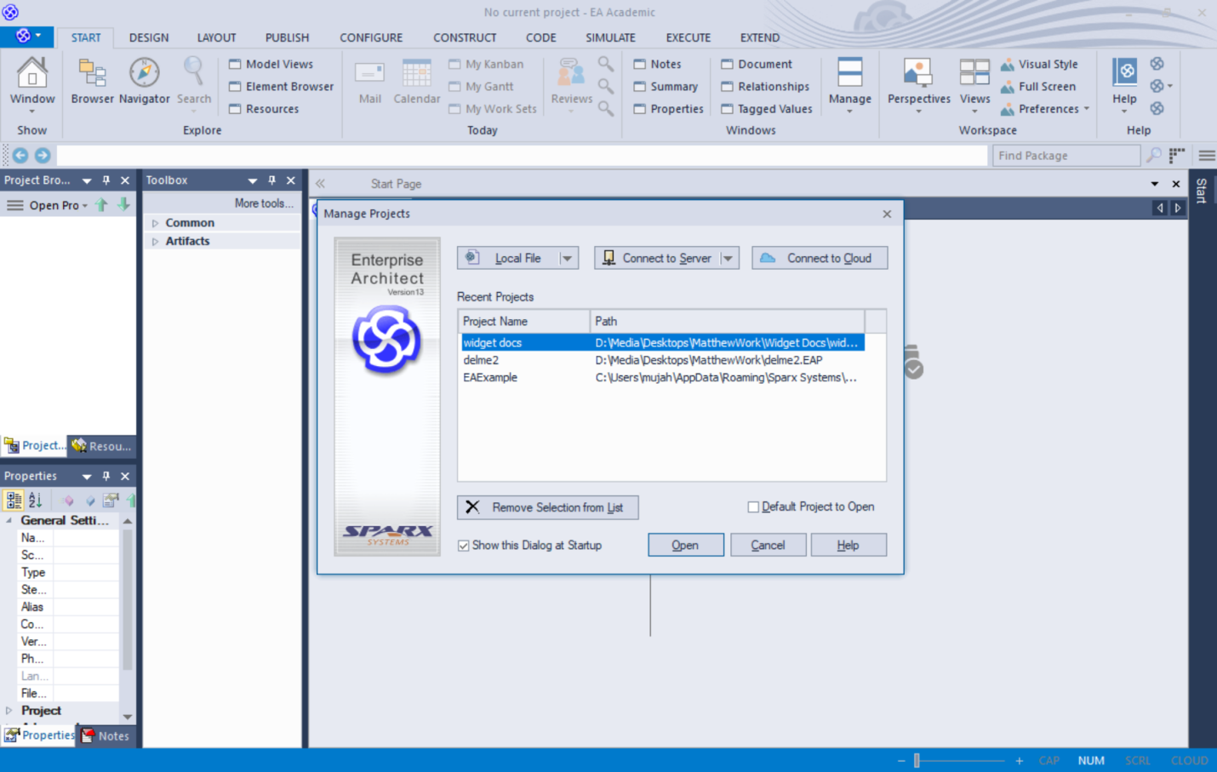
The first step is to create a new project
A project contains the different views of the system.
The views we are going to create for this system are as follows...
- Data Model View (Data Layer)
- User Model View (Presentation Layer)
- Structural View (Middle Layer)
- Dynamic View (Sequence)

Create a new Project
To create a new project, select New Project from the opening screen.
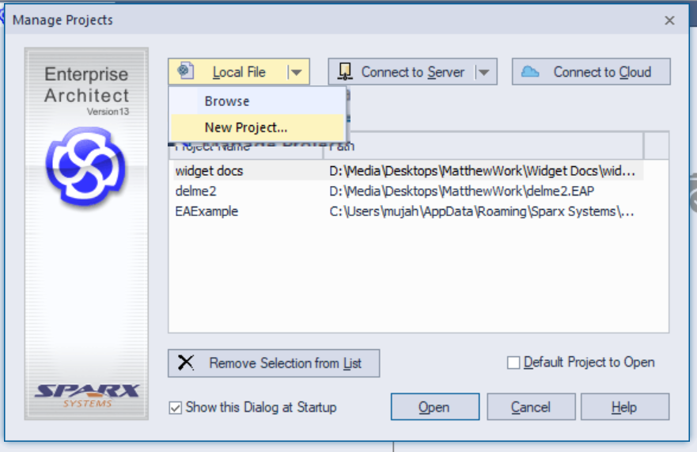
This will allow you to specify where you want to create the new project in the file system.
In this case I will create a set of documents for my widget management system...
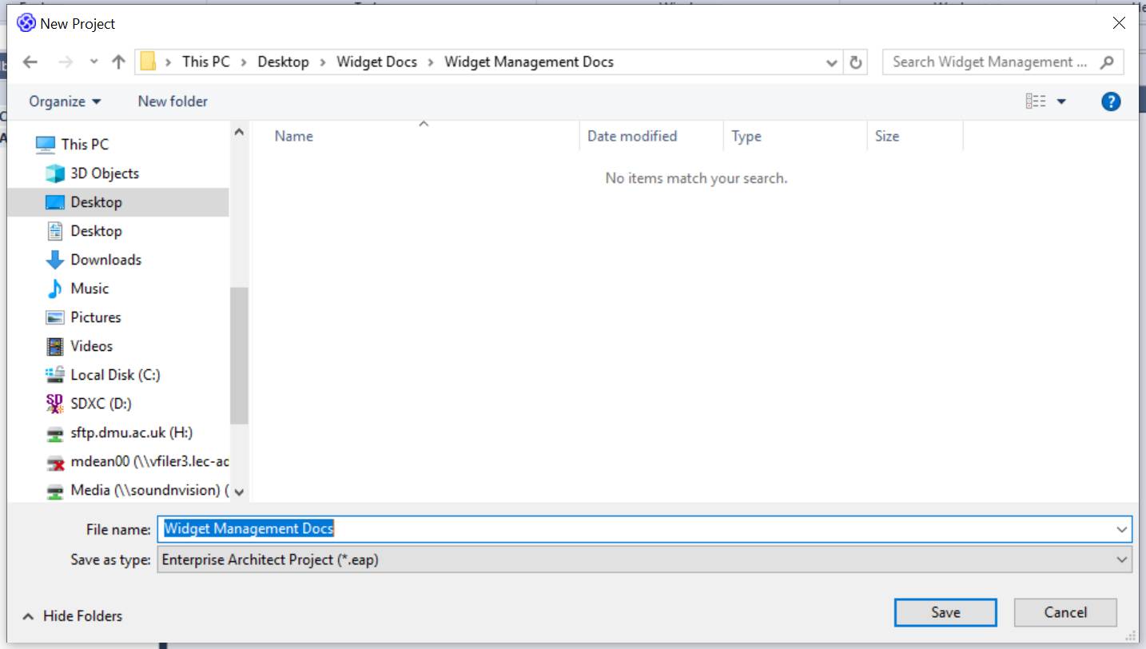
Give the project a sensible name and press Save. You should see the following screen appear...
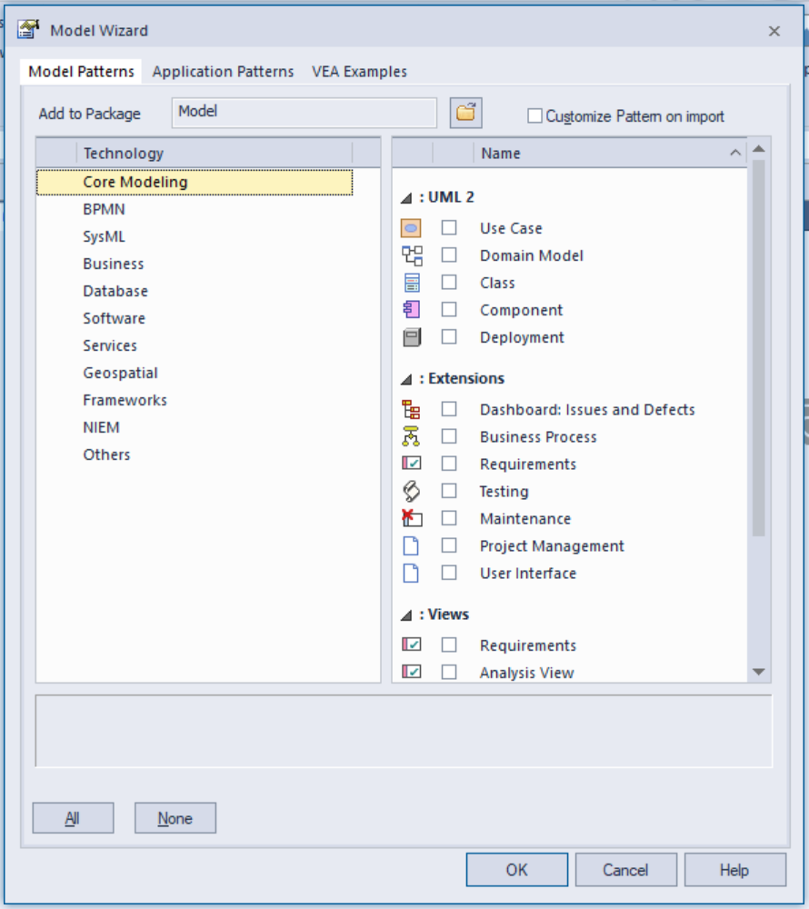
EA will then ask you what sort of project you are working on. Make sure that Core Modelling UML 2 Technology is selected.
For this example make sure that there are no ticks in the following section (we will do this manually).
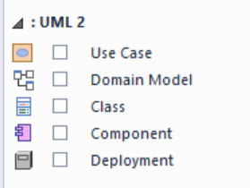
Press OK and after a few moments the system will settle down. On the left of the interface you will see your model in the project browser…
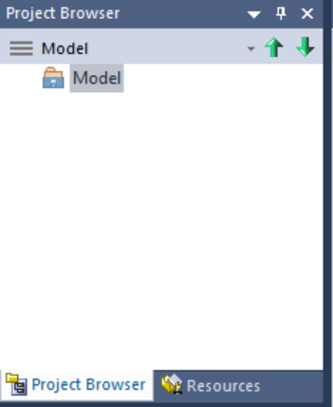
Not terribly exciting or useful!

Creating System Views
What we want to do next is create sections in the model to store the different views of the system.
A view is a way of looking at the system.
Right click on the model and select add view.
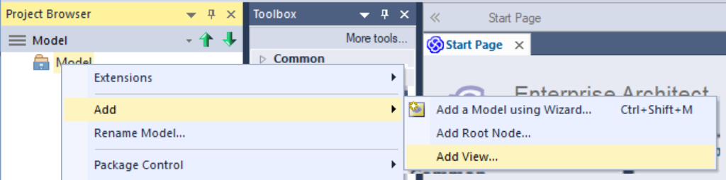

Enter the following for the first view selecting Use Case as the icon stlye...
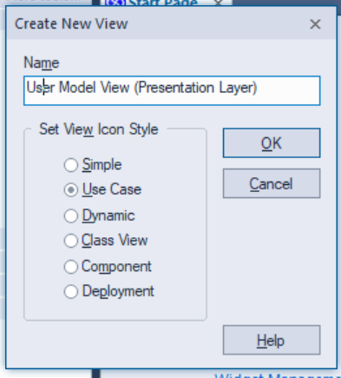
Press OK and you should see the view created in your model.
Now create the remaining views…
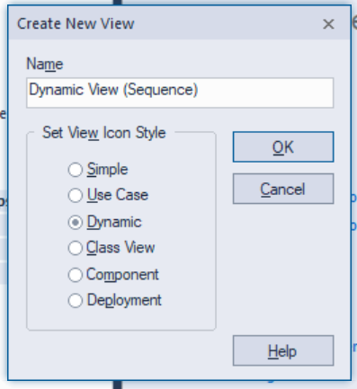
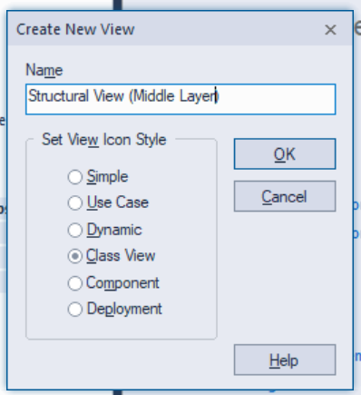
finally...
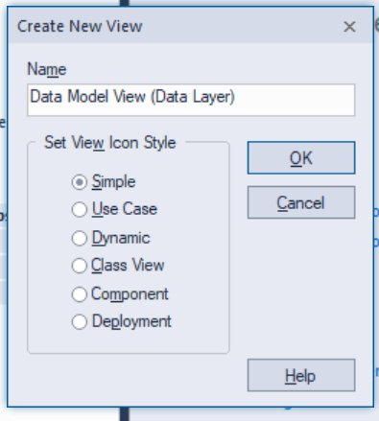
Such that the model looks something like this...
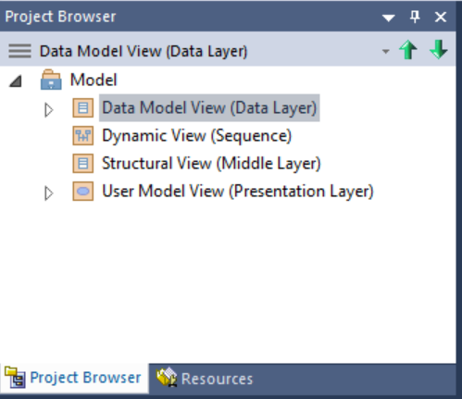

Creating the ERD
To add a diagram to a view we need to right click on the view and add a new diagram...
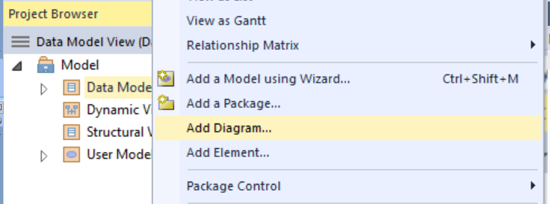
In this case we want to add an ERD to the view...
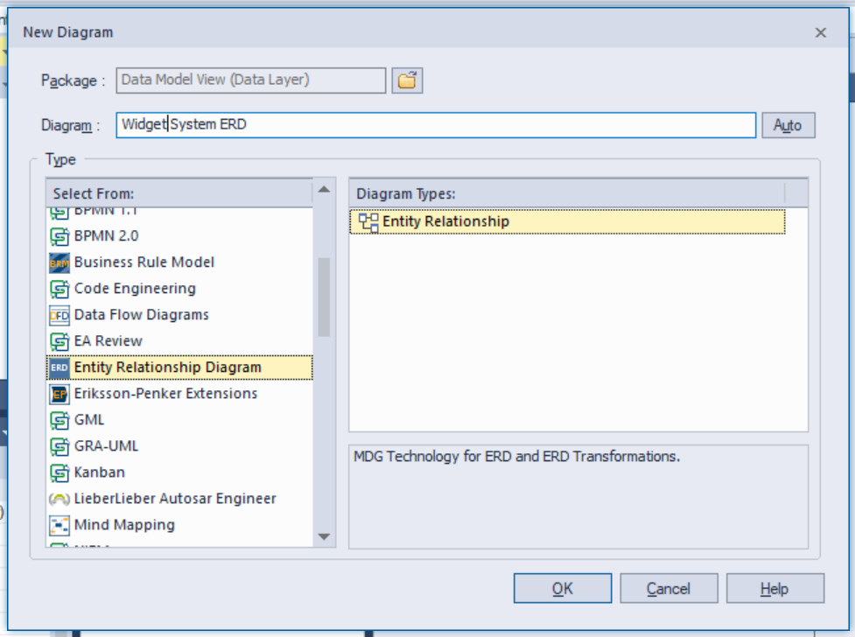
Locate Entity Relationship Diagram in the left hand pane and give the new diagram a sensible name.
Press OK and a blank ERD will be created for you.
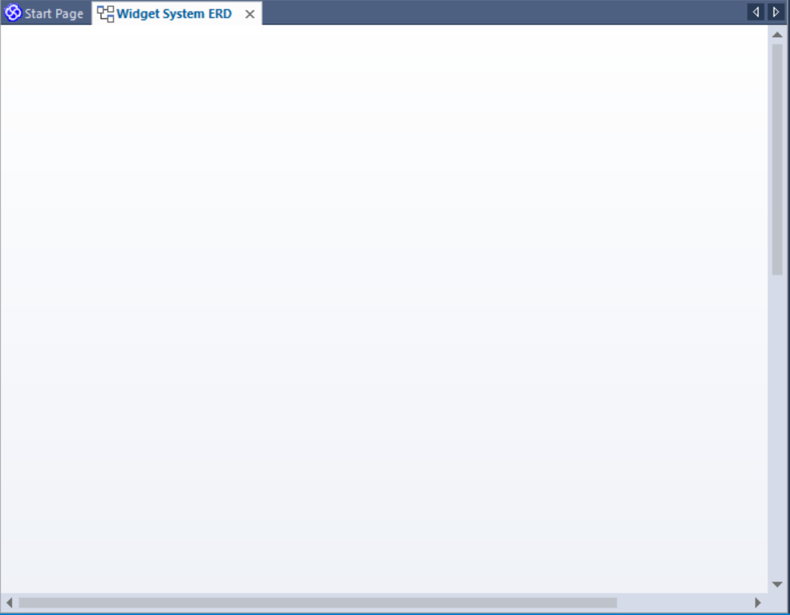

Creating Entities
Once you get the hang of using the drawing tools in EA they are pretty much the same for all diagrams.
Diagram elements are found in the Toolbox...
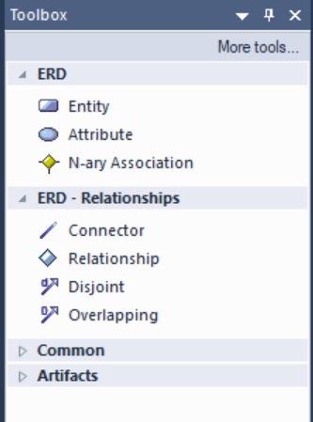
In this case we will add an entity called Widget.
Click once on the Entity icon in the toolbox...
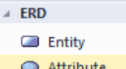
Then click on the white canvas of the new diagram you should get the following screen...
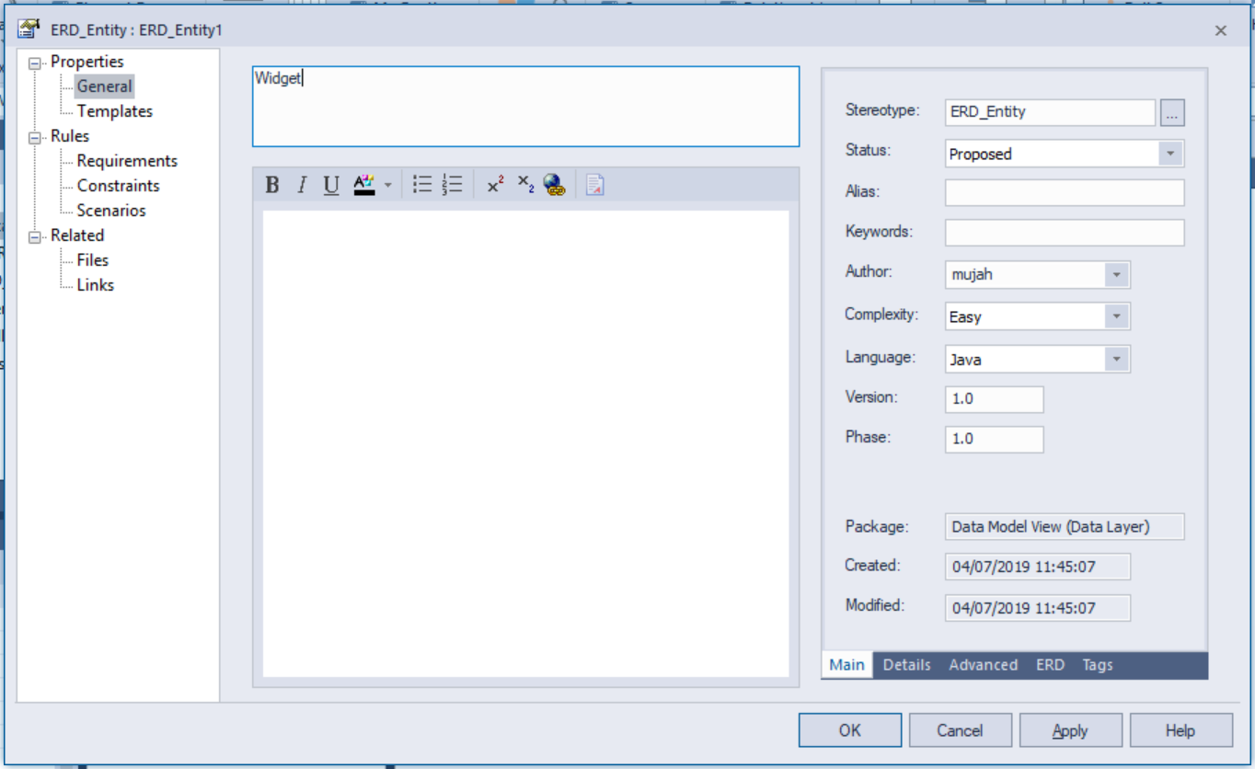
Enter the name of the entity at the top and press OK.
You should now see the entity in the diagram...
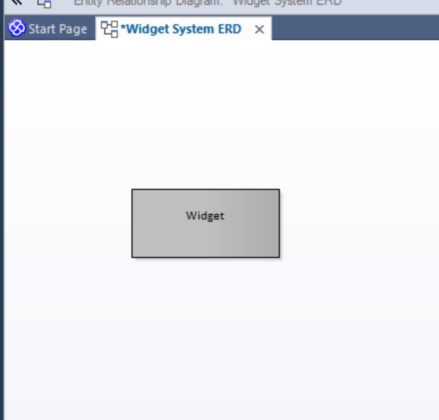
Let’s create one more entity so that we may play with the relationships tool in a moment.
Create a second entity called Manufacturer...
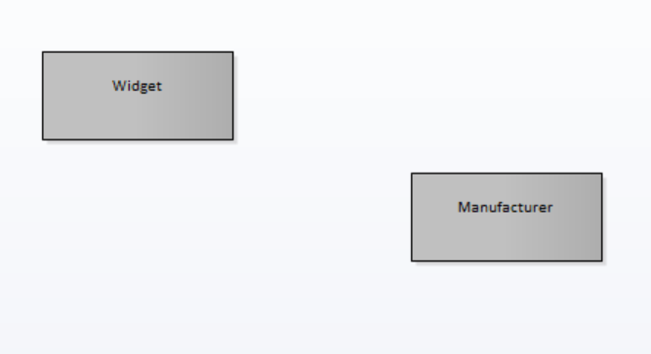

Creating Relationships
Again in the toolbox select the relationship tool...
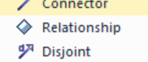
Click on one of the entities and drag the mouse to the second entity, you should see an effect similar to this...
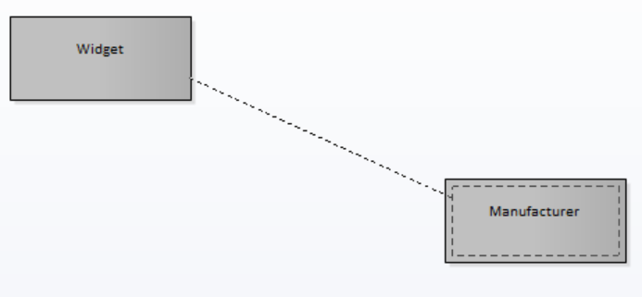
Once you let go you should see the new relationship...
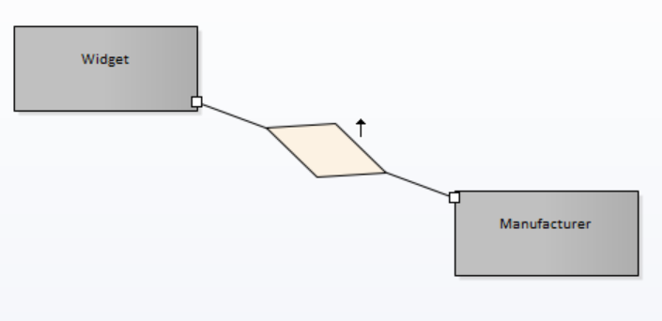
Right click on the relationship to edit its properties...
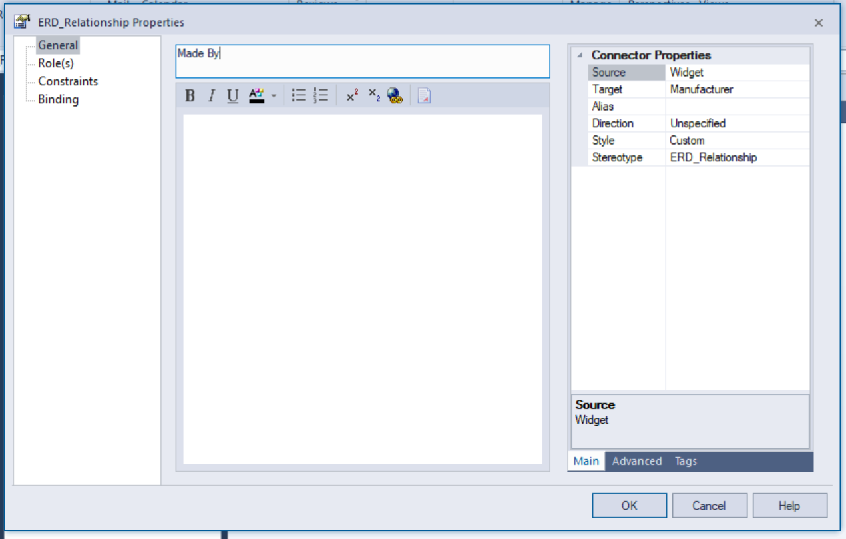
Press OK and you should see the text displayed for the relationship...
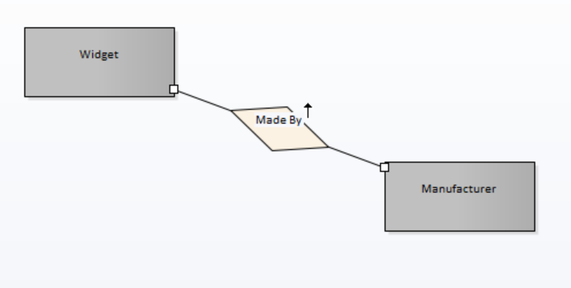

Specifying Multiplicity
Once you have a relationship set up you are in a position to specify the multiplicity.
Right click on one end of the relationship and select Multiplicity and Other...
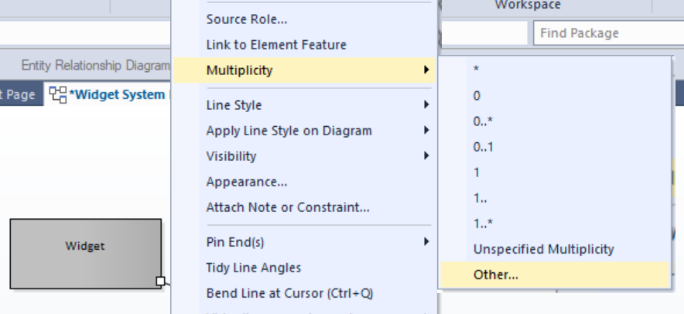
You then have the option to specify the multiplicity by typing or use the drop down list to use an existing setting...
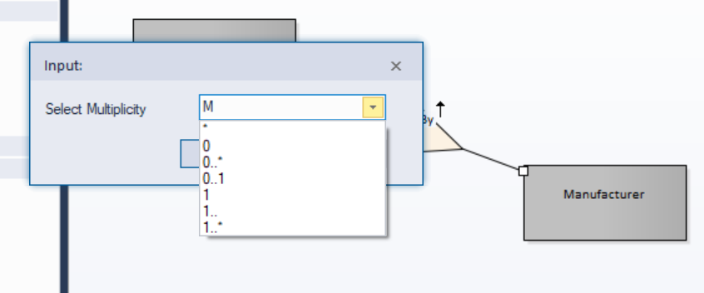
In this example since we are using Chen we will enter M as the multiplicity (Many).
Set up the other end of the relationship like so...
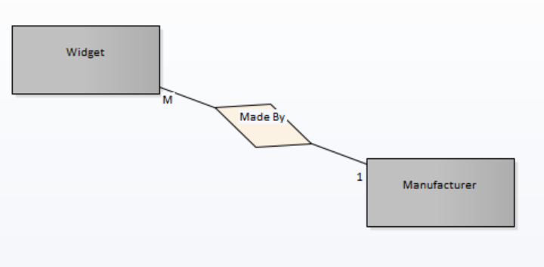
In our business rules, Widgets are unique bespoke items created by a single manufacturer.
A manufacturer however makes a range of these widgets.
If I want a specific widget I would have to contact the maker of that widget.
Be clear, in the early stages of development there will be plenty wrong with the data model. When you meet with your tutor in the sprint meetings you will be able to discuss your design and work out any issues.

